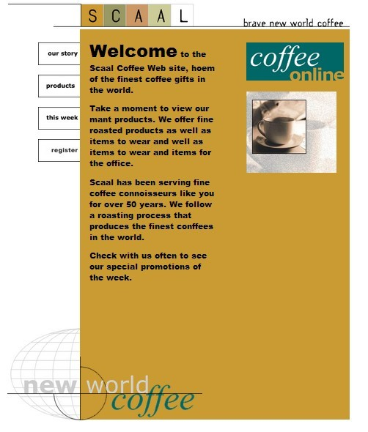

SCAAL

**our story Welcome to the**

**products**

this week

**register**

**Scaal Coffee Web site, hoem**

of the finest coffee gifts in the world.

**Take a moment to view our mant products. We offer fine roasted products as well as items to wear and well as items to wear and items for the office.**

Scaal has been serving fine coffee connoisseurs like you for over 50 years. We follow a roasting process that produces the finest conffees in the world.

**Check with us often to see our special promotions of the week.**

brave new world coffee

*coffee*

online

new world

*coffee*